Data Engineering Slot 1: Job Crawling

Author: Michael Peter Schmid
Version 1.0
Last updated: 14.10.2025

Website Structure
I decided to use jobs.ch since in my opinion jobs.ch structure is easier to understand than indeed.ch. After exploring and navigating on jobs.ch as well as inspecting the page html code, I document my important findings:

- As a first step I visited https://www.jobs.ch/de/ and then I scrolled down to “Jobs nach Berufsgruppen” This way I can filter for the jobs field I’m interested in.
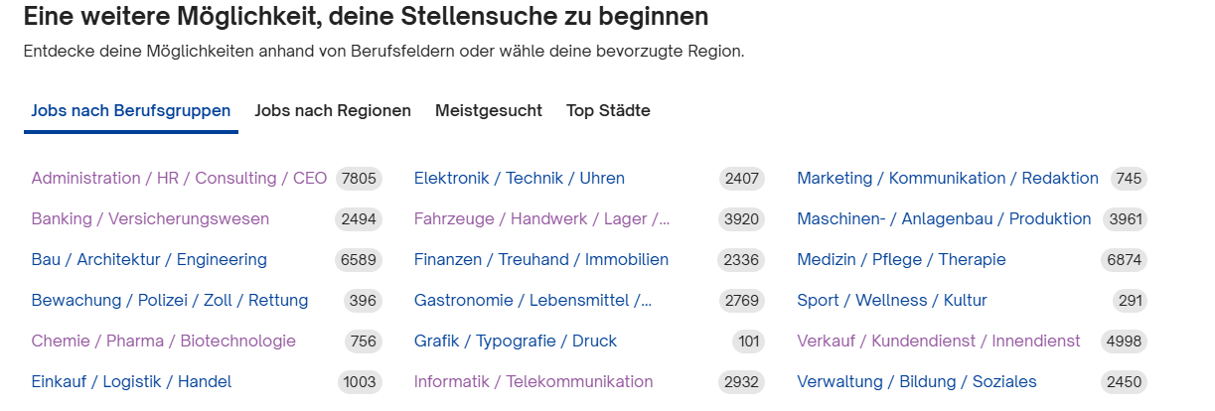

- Now when clicking on a link for example: https://www.jobs.ch/de/stellenangebote/informatik-telekommunikation/
One will be directed to a site, where jobs in that field are displayed in the sidebar.
And there are 100 subpages. It is possible to navigate trough these subpage by appending ?page={number} where number is a between 0 and 100.
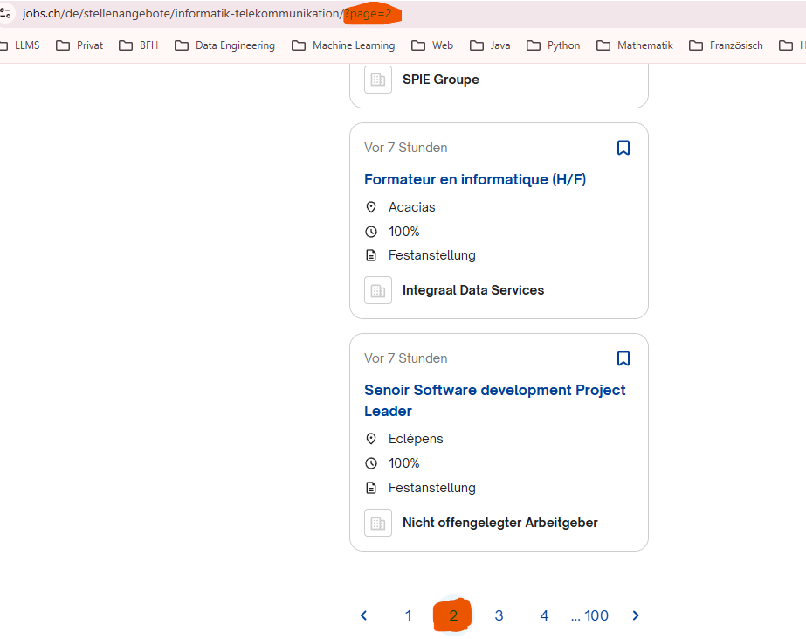

- Now if we inspect the source code at this point we see that there is a div for each “job box” and within this div tag is an anker tag which contains the specific job id:
So for each page there are multiple job id’s inside these divs.
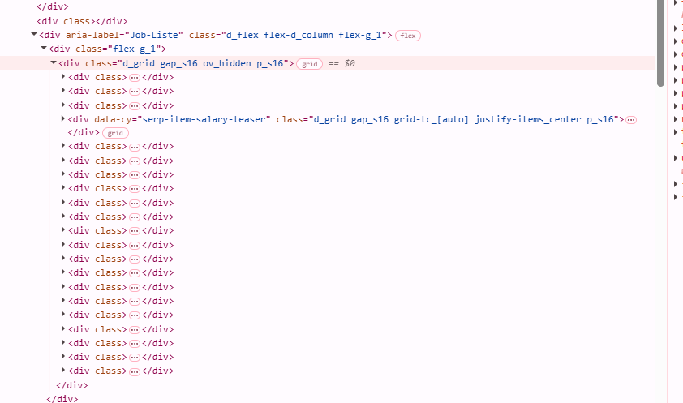

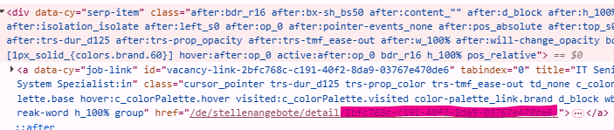

Strategy
Based on what I described in the previous chapter, here’s my strategy for this task:
- Pick some “Berufsgruppen” that I’m interested in. (in my case:
"informatik-telekommunikation", "finanzen-treuhand-immobilien")
- Collect Jobs for each “Berufsgruppe” for each page by calling https://www.jobs.ch/de/stellenangebote/{Berufsgruppe}/?page={number}
Return the result for each page (number) and collect all the job-ids
- Call https://www.jobs.ch/de/stellenangebote/detail/{job_id} / for each previously collected job id: For each result make a new file and write the result in it.

Limitations
- One script-run takes over 60min
- Only applicable to jobs.ch
- Tight coupling: Script will fail, if jobs.ch teams decide to change it’s website structure or even renaming job field categories or other variable names in the URL.

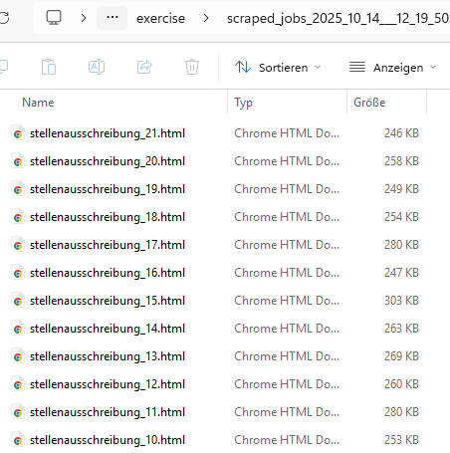
Results

- A directory with job html pages:

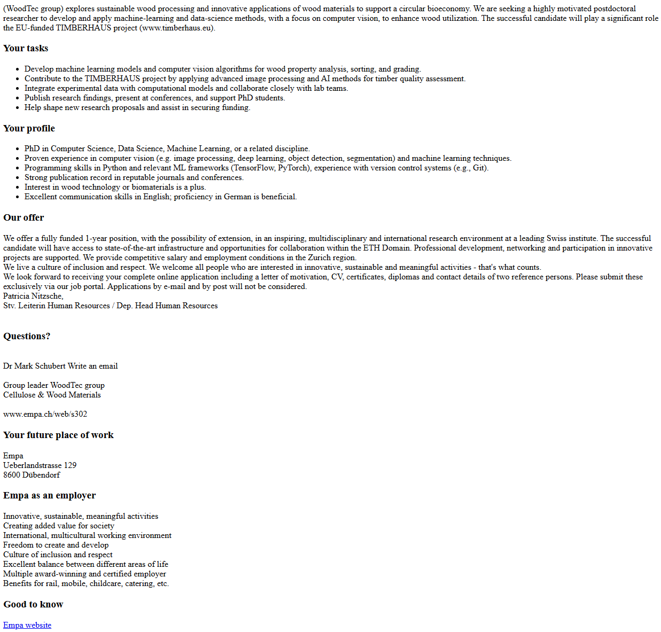
- If one page is opened one can scroll down and will find the job description
example:

